PROCUREMENT & SPEND ANALYSIS SQL QUERIES

KPIs
1.TOTAL SPEND PER SUPPLIER
SELECT Supplier,
CAST(SUM(Negotiated_Price * Quantity)AS DECIMAL(10,2)) AS Total_Spend
FROM Procurement_DA
GROUP BY Supplier
ORDER BY Total_Spend DESC;
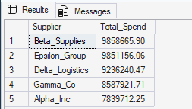

2.AVERAGE DELIVERY DELAY
SELECT Supplier,
AVG(Delay_Days) AS Avg_Delay
FROM Procurement_DA
GROUP BY Supplier;
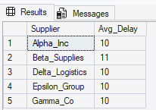
3. DEFECT RATE
SELECT Supplier,
CAST(SUM(Defective_Units)*1.0 / SUM(Quantity)AS DECIMAL(10,2))AS Defect_Rate
FROM Procurement_DA
GROUP BY Supplier;
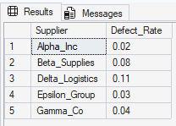

4.COMPLIANCE COUNT
SELECT Compliance, COUNT(*) AS Compliance_count
FROM Procurement_DA
GROUP BY Compliance;
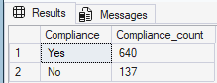

5.TOP 10 PURCHASE ORDER
SELECT TOP 10 PO_ID, CAST((Negotiated_Price * Quantity)/10 AS DECIMAL(10,1))AS PO_Value
FROM Procurement_DA
ORDER BY PO_Value DESC;
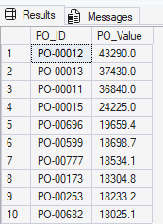

6.ORDERS AT RISK
SELECT Order_Status , COUNT(*) AS Status
FROM Procurement_DA
WHERE order_Status IN ('Pending', 'Cancelled')
GROUP BY Order_Status;
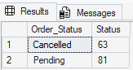

7.SUPPLIER RISK SCORE
SELECT Supplier,
CAST(((SUM(Defective_Units)*1.0 / SUM(Quantity))*0.5
+ (1 - AVG(CAST(On_Time AS FLOAT)))*0.3
+ (AVG(Delay_Days)/30)*0.2) AS DECIMAL(10,2))AS Risk_Score
FROM Procurement_DA
GROUP BY Supplier
ORDER BY Risk_Score DESC;
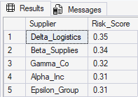

8.AVERAGE NEGOTIATED PRICE BY CATEGORY
SELECT Item_Category,
CAST(AVG(Negotiated_Price) AS DECIMAL(10,2))AS Avg_Negotiated_Price
FROM Procurement_DA
GROUP BY Item_Category
ORDER BY Avg_Negotiated_Price DESC;
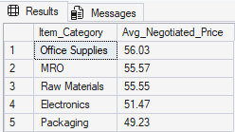

9.AVERAGE SAVINGS BY CATEGORY
SELECT Item_Category,
CAST(AVG(Unit_Price - Negotiated_Price) AS DECIMAL(10,2)) AS Avg_Savings
FROM Procurement_DA
GROUP BY Item_Category
ORDER BY Avg_Savings DESC;
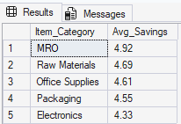
10. TOTAL COST SAVINGS
SELECT
CAST(SUM(Unit_Price - Negotiated_Price)AS DECIMAL(10,2)) AS Total_Savings
FROM Procurement_DA;
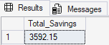

11.SPEND PER ITEM CATEGORY
SELECT Item_Category,
CAST(SUM(Negotiated_Price * Quantity)AS DECIMAL(10,2)) AS Category_Spend
FROM Procurement_DA
GROUP BY Item_Category
ORDER BY Category_Spend DESC;
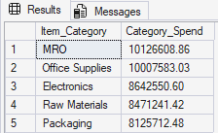

12.FREQUENTLY ORDERED ITEM CATEGORY
SELECT Item_Category,COUNT(*) AS Order_Count
FROM Procurement_DA
GROUP BY Item_Category
ORDER BY Order_Count DESC;
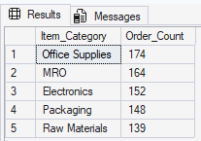

DIMENSION TABLES

1.DIM_SUPPLIER
CREATE TABLE dim_supplier (
SupplierID INT IDENTITY PRIMARY KEY,
Supplier VARCHAR(255));
INSERT INTO dim_supplier (Supplier)
SELECT DISTINCT Supplier
FROM Procurement_DA;
SELECT * FROM DIM_SUPPLIER
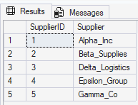

2. DIM_ITEM
CREATE TABLE dim_item (
ItemID INT IDENTITY PRIMARY KEY,
Item_Category VARCHAR(255));
INSERT INTO dim_item (Item_Category)
SELECT DISTINCT Item_Category
FROM Procurement_DA;
SELECT * FROM DIM_ITEM
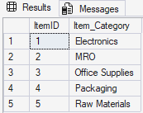

3.DIM_STATUS
CREATE TABLE dim_status (StatusID INT IDENTITY PRIMARY KEY,
Order_Status VARCHAR(50));
INSERT INTO dim_status (Order_Status)
SELECT DISTINCT Order_Status
FROM procurement_DA;
SELECT * FROM DIM_STATUS
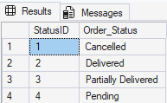

4.DIM_TIME
CREATE TABLE dim_date (
DateID INT IDENTITY PRIMARY KEY,
FullDate DATE,
Year INT,
Month INT,
Day INT);
INSERT INTO dim_date (FullDate, Year, Month, Day)
SELECT DISTINCT
d.DateValue,
YEAR(d.DateValue),
MONTH(d.DateValue),
DAY(d.DateValue)
FROM (
SELECT Order_Date AS DateValue FROM Procurement_DA
UNION
SELECT Delivery_Date FROM Procurement_DA
) d
WHERE d.DateValue IS NOT NULL;
SELECT TOP 10 * FROM DIM_DATE
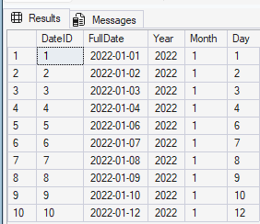

FACT TABLE

FACT_PROCUREMENT
CREATE TABLE fact_procurement (
PO_ID VARCHAR(50),
SupplierID INT,
ItemID INT,
OrderDateID INT,
DeliveryDateID INT,
Quantity INT,
Unit_Price DECIMAL(10,2),
Negotiated_Price DECIMAL(10,2),
Defective_Units INT,
Compliance VARCHAR(50),
Delay_Days INT,
On_Time INT,
FOREIGN KEY (SupplierID) REFERENCES dim_supplier(SupplierID),
FOREIGN KEY (ItemID) REFERENCES dim_item(ItemID),
FOREIGN KEY (OrderDateID) REFERENCES dim_date(DateID),
FOREIGN KEY (DeliveryDateID) REFERENCES dim_date(DateID));
INSERT INTO fact_procurement (
PO_ID, SupplierID, ItemID, OrderDateID, DeliveryDateID,
Quantity, Unit_Price, Negotiated_Price,
Defective_Units, Compliance, Delay_Days, On_Time
)
SELECT
p.PO_ID,
s.SupplierID,
i.ItemID,
od.DateID,
dd.DateID,
p.Quantity,
p.Unit_Price,
p.Negotiated_Price,
p.Defective_Units,
p.Compliance,
p.Delay_Days,
p.On_Time

FROM Procurement_DA p
JOIN dim_supplier s
ON p.Supplier = s.Supplier
JOIN dim_item i
ON p.Item_Category = i.Item_Category
LEFT JOIN dim_date od
ON p.Order_Date = od.FullDate
LEFT JOIN dim_date dd
ON p.Delivery_Date = dd.FullDate;
SELECT TOP 10 * FROM FACT_PROCUREMENT
